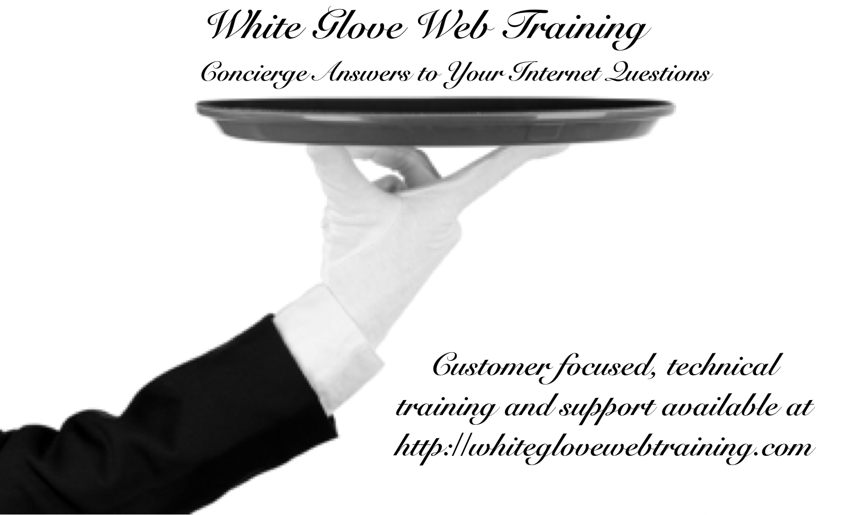
A website is more than an online business card. It can be an integral part of your business and sometimes the main focus of a business. Building a powerful website requires understanding your business, your customers, and your goals. Take time to plan ahead in order to have the most successful site possible.

If you don’t yet have solid answers for some of these questions, that’s okay. Just make sure you are working on them in order to answer them in the near future.
Website Planning Guide
Presented by Kim Shivler, owner White Glove Web Training

Table of Contents

Section 1: About Your Business 3
Section 2: Your Website Strategy 5
Section 3: Site Layout 7
About Kim Shivler 8

Section 1: About Your Business
In this section, you will describe your business in detail. Understanding your business helps you understand the purpose of your website.

Describe your business. What do you do or sell?

Who is your target customer?

Are you a local business with a local storefront wanting to drive traffic to your location from your website?
Example:
Restaurants and service professionals like attorneys and accountants frequently fall into this category
In a Perfect World, what would your day look like?
This step is optional, but I suggest answering it for yourself even if you don’t share. I find it helps people scope their business offline and online.

Are you satisfied with the current success of your business (if just starting, skip this). If not, describe what you would like to see improved. If you are happy with your business, please describe what is going well.

Section 2: Your Website Strategy
A website is more than just a pretty page
This section will help you define the purpose of your website and how it will serve your business. This will help us build the right site for your needs.
Is this website your Core business or a part of your business?
Explanation:
For example, some websites are the online version of a company. They may sell items, act as a calling card, and provide information, but the business still has another purpose or location like a storefront. Some websites are a complete business.

Are you planning to sell products on your site? (Note this is not for shopping cart/ecommerce options. It is for those who might sell 1-5 products like a book or consulting package).
If you plan on creating a shopping cart site, that is more advanced - see below.

If Yes Above:
Are you going to take credit cards in a way other than PayPal? ____________
How many products do you plan to sell? ___________
Please describe these products.

Will you sell more than 8 products, products that require inventory, sales tax tracking, or otherwise need a shopping cart or ecommerce solution? If yes, please describe. *In this case, let’s discuss a shopping cart solution.

Section 3: Site Layout

Do you have a logo for your company?
Other than the logo, do you already have other images and photographs designated for use on the site?
Do you currently have a color scheme selected for the site?
Will your site have a blog?
* A blog is a collection of articles or posts that add content to your site. Visit the White Glove Web Training WordPress Basics Blog for an example: https://whiteglovewebtraining.com/blog/

About Kim Shivler
Kim Shivler, M.Ed. has worked as a writer, instructor, developer and serial entrepreneur for over 20 years. Her business experience includes computer network and database administration, technical training and writing, project management, web development, and work as an aesthetician and spa owner. She also worked for large corporations including Tivoli, an IBM company, where she was part of the worldwide technical sales and marketing team.
She holds a Bachelor of Arts in English and Master of Education degree in secondary English education from the University of Florida.

